Face Detection And Crowd Monitering System

In Public Places

E Indhuja

*Department of Computer Science and*

*Engineering*

*Kalasalingam academy of research and*

*Education*

*Krishnankoil, Virudhunagar, Tamil*

*Nadu, India*

[*indhujait16@gmail.com*](mailto:indhujait16@gmail.com)

Kampasati Mahesh

*Department of Computer Science and*

*Engineering*

*Kalasalingam academy of research and*

*Education*

*Krishnankoil, Virudhunagar, Tamil*

*Nadu, India*

[*maheshkampasati12@gmail.com*](mailto:maheshkampasati12@gmail.com)

Rahul Sharma

*Department of Computer Science and*

*Engineering*

*Kalasalingam academy of research and Education*

*Krishnankoil, Virudhunagar, Tamil*

*Nadu, India*

[*rs9489995@gmail.com*](mailto:rs9489995@gmail.com)

Mohammad Mazid

*Department of Computer Science and*

*Engineering*

*Kalasalingam academy of research and*

*Education*

*Krishnankoil, Virudhunagar, Tamil*

*Nadu, India*

[*mohammadmazid996@gmail.com*](mailto:mohammadmazid996@gmail.com)

Pantham Satya

*Department of Computer Science and*

*Engineering*

*Kalasalingam academy of research and*

*Education*

*Krishnankoil, Virudhunagar, Tamil*

*Nadu, India*

[*satyapantham3@gmail.com*](mailto:satyapantham3@gmail.com)

**ABSTRACT: In today's increasingly crowded and dynamic public spaces, ensuring safety and security is of paramount importance. Traditional methods of surveillance often struggle to provide real-time monitoring and accurate detection of potential threats within large crowds The face detection component of the system utilizes convolutional neural networks (CNNs) to accurately detect and recognize faces in real-time, even in challenging conditions such as varying lighting and occlusions. By training the CNN on diverse datasets, the system achieves robust performance across different environments and scenarios. Complementing the face detection module, the crowd monitoring component employs computer vision algorithms to analyze crowd dynamics, density, and movement patterns. This enables the system to detect anomalies and potential security threats within the crowd, providing security personnel with valuable insights to take timely and appropriate actions**.

**The integration of face detection and crowd monitoring capabilities into a unified system offers several advantages. It enhances situational awareness by providing real-time information about individuals of interest and crowd behaviour, thereby enabling proactive security measures. Moreover, the system minimizes false alarms and improves response times, contributing to more effective security management in crowded environments.**

***Keywords:***

Face detection,Crowd Monitoring,Surveillance, Convolutional neural networks (CNNs)

1. **INTRODUCTION**

The need for ensuring safety and security in crowded public spaces is more pressing than ever in today's society. Locations such as transportation hubs, stadiums, and urban centers face constant challenges in effectively monitoring crowds and swiftly detecting potential security threats. Traditional surveillance methods, reliant on manual observation or rudimentary algorithms, often struggle to keep pace with the dynamic and intricate nature of crowd behaviour. This paper introduces a pioneering approach to address the complexities of crowd monitoring and face detection through the integration of advanced computer vision techniques and deep learning algorithms. Specifically, we leverage Convolutional Neural Networks (CNNs) and Long Short-Term Memory (LSTM) networks, two powerful architectures in the realm of deep learning, to develop a comprehensive system for automated detection of individuals of interest within crowded environments and analysis of crowd behaviour to identify potential security threats The primary goal of this paper is to present a unified framework that harnesses the combined strengths of CNNs and LSTM networks for face detection and crowd monitoring, respectively. We will delve into the underlying principles of each component, illustrating how they synergize to enhance situational awareness and enable proactive security measures in crowded public spaces. The initial focus of our discussion will be on face detection, where we employ CNNs to accurately detect and recognize faces in real-time. We will explore the inherent challenges associated with face detection in crowded environments and detail our innovative approach for overcoming these obstacles. Following that, we will turn our attention to the crowd monitoring component, where we utilize LSTM networks to analyze crowd dynamics, density, and movement patterns. By leveraging the temporal dependencies inherent in crowd behaviour, our system can effectively detect anomalies and potential security threats within the crowd, empowering security personnel with timely insights to take appropriate actions. Furthermore, we will highlight the seamless integration of face detection and crowd monitoring capabilities into a unified system, showcasing the advantages of leveraging CNNs and LSTM networks in tandem. Through practical examples and case studies, we will demonstrate the effectiveness of our approach in real-world scenarios.

**Architecture:**

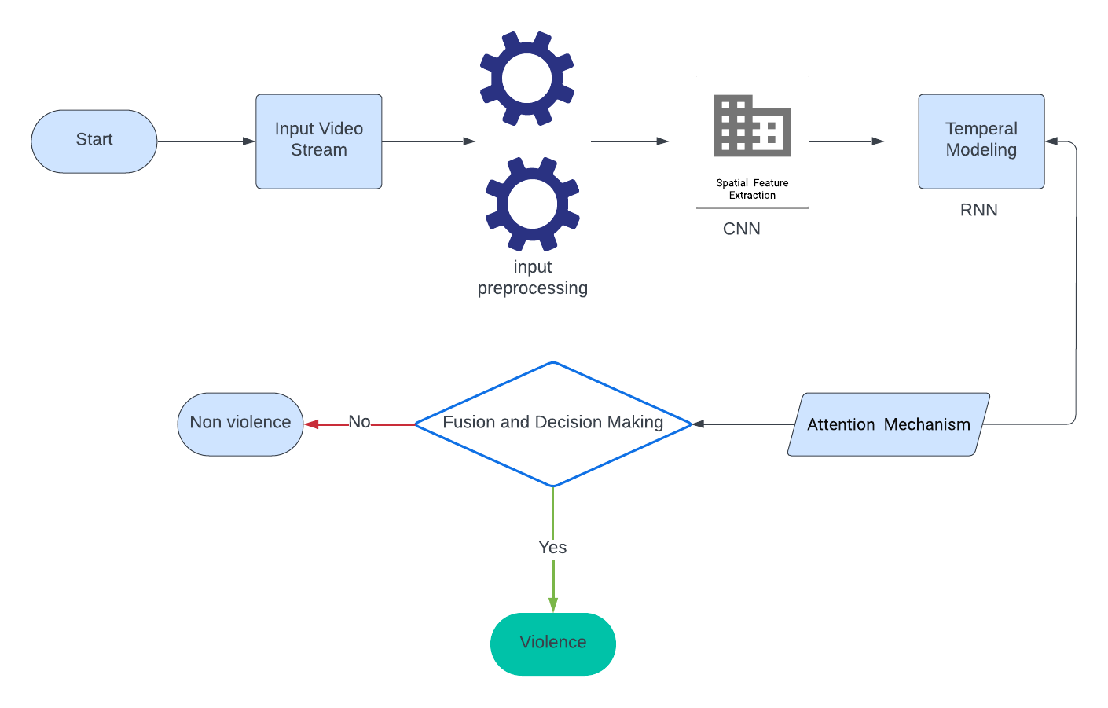

**Fig.1.** Architecture

**Rationale for the Study:**

Face detection and crowd monitoring systems offer a promising solution to these challenges by leveraging advanced computer vision techniques and deep learning algorithms. The rationale for this study is multifaceted and encompasses several key considerations

**Enhanced Situational Awareness**: By developing a robust face detection system, security personnel can efficiently identify individuals of interest within crowded environments. This capability enhances situational awareness and enables proactive measures to be taken in response to potential security threats.

**Real-time Threat Detection**: Crowd monitoring systems equipped with advanced computer vision algorithms enable the real-time analysis of crowd dynamics, density, and movement patterns. This allows for the detection of anomalies and suspicious behaviors, facilitating rapid response and mitigation of security incidents.

**Importance of Face Detection And Crowd Monitering System :**

The significance of face detection and crowd monitoring systems in contemporary society cannot be overstated, particularly in the realm of public safety and security. These technologies play a pivotal role in safeguarding crowded environments, such as transportation hubs, stadiums, and urban centers, from various security threats and emergencies. The importance of integrating face detection and crowd monitoring into comprehensive surveillance systems is multifaceted and encompasses several key aspects.

**Enhanced Threat Detection**: Face detection and crowd monitoring systems enable security personnel to detect potential threats and suspicious activities in real-time. By accurately identifying individuals and analyzing crowd behaviour, these systems provide early warning signs of security incidents, allowing for timely intervention and prevention.

**Proactive Security Measures**: These technologies empower security teams to take proactive measures to mitigate security risks and maintain public order. By continuously monitoring crowded environments and identifying anomalies, security personnel can deploy resources strategically and implement preemptive measures to deter criminal activities and ensure public safety.

**Optimized Resource Allocation**: Face detection and crowd monitoring systems optimize the allocation of security resources by focusing attention on areas or individuals that pose the highest risk. By automating surveillance processes and providing actionable insights, these systems enable security personnel to prioritize their efforts effectively, maximizing the efficiency of security operations.

**Emergency Response Preparedness**: In the event of emergencies, such as accidents, natural disasters, or terrorist attacks, face detection and crowd monitoring systems are instrumental in facilitating emergency response efforts. By quickly identifying affected individuals and coordinating rescue operations, these systems help minimize casualties and ensure a swift and coordinated response to emergencies.

**Public Confidence and Trust**: Effective implementation of face detection and crowd monitoring systems enhances public confidence in the safety and security of crowded public spaces. Knowing that measures are in place to detect and respond to security threats instills a sense of trust and reassurance among individuals, encouraging them to participate in public events and activities without fear.

**Data-Driven Decision Making**: These technologies generate valuable data and insights that can be used for data-driven decision-making and long-term security planning. By analyzing patterns of behaviour and identifying trends, security agencies can develop proactive strategies to address emerging threats and improve overall security preparedness.

1. **LITERATURE SURVEY**

In paper[1] "MobileNetV2: Inverted residuals and linear bottlenecks," Sandler et al. introduce MobileNetV2, an innovative architecture tailored for efficient deep learning on mobile and embedded devices. MobileNetV2 builds upon the original MobileNet framework by introducing inverted residuals and linear bottlenecks. These features optimize computational efficiency by employing lightweight bottleneck layers, depth wise convolutions, and linear projections, reducing the computational burden while maintaining high performance. The authors demonstrate the effectiveness of MobileNetV2 through extensive experiments across various computer vision tasks, including image classification, object detection, and semantic segmentation. Results show that MobileNetV2 outperforms previous architectures while requiring fewer parameters and computational resources, making it highly suitable for deployment on resource-constrained devices. Overall, MobileNetV2 represents a significant advancement in efficient deep learning architectures, offering a practical solution for real-world applications where computational efficiency is paramount.

Top of Form

In paper[2] The conclusion of "Very Deep Convolutional Networks for Large-Scale Image Recognition" by Simonyan and Zisserman highlights the significant advancements made in deep convolutional neural network (CNN) architectures, particularly the VGG models. Through rigorous experimentation on benchmark datasets like ImageNet, the authors demonstrate the superior performance of deeper CNNs in image classification tasks. They emphasize the critical role of depth in capturing complex hierarchical features, essential for accurately recognizing and classifying diverse images. Additionally, the conclusion underscores the importance of simplicity and uniformity in network design, as exemplified by the straightforward architecture of the VGG models, comprising repeated convolutional and max-pooling layers. This simplicity not only facilitates training and optimization but also ensures efficient utilization of computational resources. Overall, the research findings highlight the effectiveness of very deep convolutional networks like VGG in achieving state-of-the-art results in large-scale image recognition. These insights contribute significantly to the field of computer vision, providing guidance for designing deep learning models optimized for image classification tasks on a broad scale. Incorporating these findings into a literature review offers valuable perspectives on the evolution and impact of deep CNN architectures in the realm of image recognition.

**Challenges in Face Detection And Crowd Monitering System :**

**Variability in Environmental Conditions**: Face detection and crowd monitoring systems must operate effectively under diverse environmental conditions, including varying lighting conditions, weather, and camera angles. These factors can affect the quality of image and video data, making it challenging to accurately detect faces and monitor crowd behaviour.

**Crowded Scenes and Occlusions**: In crowded environments, faces may be partially or fully occluded by other objects or individuals, posing challenges for accurate face detection. Similarly, crowd monitoring systems must contend with occlusions and overlapping individuals, making it difficult to track and analyze individual movements within the crowd.

**Real-Time Processing**: Achieving real-time processing in face detection and crowd monitoring systems is crucial for timely threat detection and response. However, the computational complexity of these tasks, especially in large-scale environments with high-resolution video streams, can pose significant challenges in achieving low-latency performance.

**Privacy Concerns**: The deployment of face detection and crowd monitoring systems raises concerns about privacy and data protection. Balancing the need for security with individual privacy rights requires careful consideration of data collection, storage, and usage practices, as well as compliance with relevant regulations and standards.

**Scalability**: Face detection and crowd monitoring systems must be scalable to accommodate varying crowd sizes and densities. Scalability challenges arise in processing and analyzing large volumes of data in real-time, as well as in deploying and maintaining systems across different locations and environments.

**Accuracy and Robustness**: Ensuring high accuracy and robustness in face detection and crowd monitoring systems is essential for reliable threat detection and decision-making. Challenges include dealing with variations in facial appearance, such as changes in pose, expression, and occlusion, as well as adapting to dynamic and unpredictable crowd behaviours.

1. **METHOD USED:**

our approach is all about breaking down the process into two main parts: first, we're using something called MobileNetV2 to pick up on visual patterns in the video frames, and then we're passing those patterns over to an LSTM network to understand the flow of events over time. Let's dive into the details.

**Data Collection and Preprocessing:**

For the crowd monitoring and face detection system, surveillance videos capturing both violent and non-violent activities are gathered from diverse sources. These videos undergo preprocessing to facilitate subsequent analysis. Initially, each video is segmented into individual frames, ensuring a frame-by-frame examination of the scene. Grayscale conversion is then applied to the frames to enhance the efficiency of face detection algorithms. This conversion simplifies the computational complexity while retaining essential features for facial recognition.Following grayscale conversion, additional preprocessing steps are implemented to standardize the frames for model input. This involves resizing each frame to a consistent resolution, ensuring uniformity across all frames. By standardizing the frame size, the system optimizes computational resources and streamlines subsequent processing steps. Moreover, consistent frame resolution facilitates seamless integration with face detection and crowd monitoring algorithms, enhancing the overall system's effectiveness.Overall, these preprocessing steps lay the groundwork for robust face detection and crowd monitoring in surveillance videos. By breaking down the videos into individual frames and applying grayscale conversion and resizing, the system prepares the data for accurate analysis of facial features and crowd behavior. This meticulous preprocessing ensures that the subsequent detection and monitoring algorithms operate efficiently, enabling the system to effectively identify and respond to both violent and non-violent activities captured in the surveillance footage.

**Face Detection and Sequence Formation:**

In the face detection and crowd monitoring system, the initial step involves employing the Haar Cascade classifier for precise face detection within each frame extracted from surveillance videos. This established classifier, specifically engineered for facial recognition, meticulously scans individual frames to identify facial features. Once faces are detected, they are distinctly outlined using bounding rectangles, providing a visual representation of the identified faces within the frame.Subsequently, the system compiles the detected frames into a cohesive sequence, forming a continuous stream of visual data for subsequent analysis. This sequential arrangement allows for the examination of facial movements and interactions over time, facilitating the tracking of individuals within the monitored environment. To ensure consistent input for subsequent processing stages, the system adheres to a fixed sequence length of 16 frames. By maintaining this standardized sequence length, the system guarantees uniformity in the input data, enabling consistent and

reliable analysis across various segments of the surveillance footage.

The integration of face detection and sequence formation establishes a robust foundation for comprehensive crowd monitoring within the surveillance videos. Through precise facial recognition and sequential organization of frames, the system can effectively track individual movements and behaviors, providing valuable insights into crowd dynamics and activities. Moreover, the standardized sequence formation ensures that the input to subsequent analysis stages remains consistent, enhancing the system's accuracy and reliability in detecting and responding to potential security threats within the monitored environment.

Top of Form

**Model Loading and Prediction:**

Pre-trained models for face detection and violence detection are loaded (Haar Cascade and MobileNetV3-LSTM, respectively).

For each sequence of frames, the violence detection model predicts the likelihood of violence occurrence.

Confidence scores are computed, and if a high-confidence prediction is made, the frame is labeled as violent.

**Email Notification for High-Confidence Predictions:**

Frames with high-confidence violence predictions (confidence > 0.9) trigger an email notification.

The email includes a timestamp, indicating the detection time, and attaches the corresponding frame image.

**Continuous Video Processing and Display:**

The surveillance video is continuously processed frame by frame.

Detected faces are highlighted in real-time, providing visual feedback to the user.

Predictions for violence and non-violence are displayed on the frame, along with the current timestamp.

**User Interaction and Termination:**

The user can terminate the video processing by pressing the 'q' key.

Upon termination, the video capture object is released, and all display windows are closed.

**Architecture Of Model :**

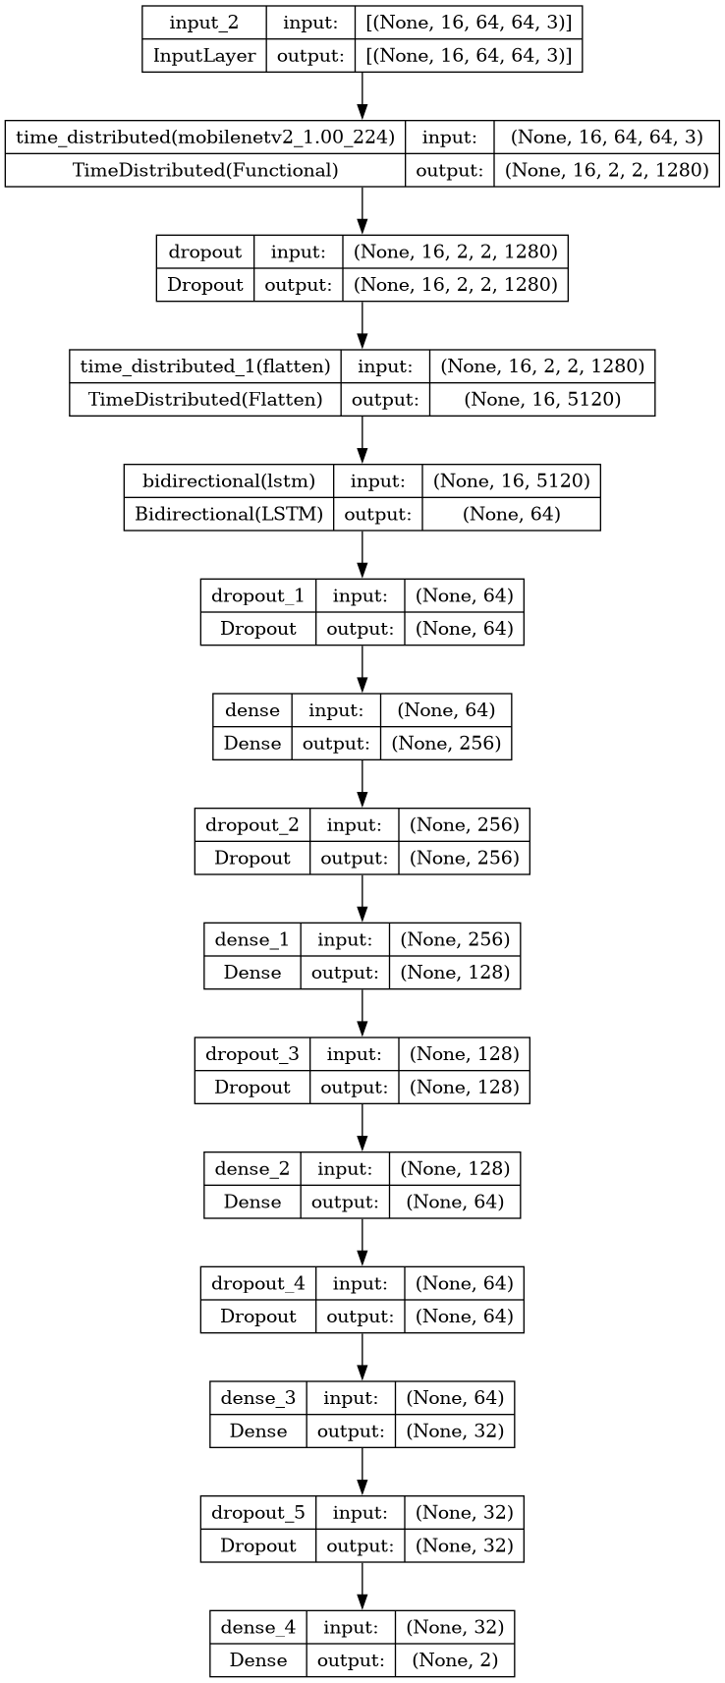

**Fig.2. :** Model Architecture

1. **Result:**

**Classification Performance Evaluation:**

The classification report for our Face detection and Crowd Monitering system is presented below, showcasing the precision, recall, and F1-score for each class:



**Fig.3. :** classification report

The accuracy of our model on the test set is reported as 89%, indicating that it correctly predicts the class labels for 89% of the samples. Additionally, the macro-average F1-score across both classes is 0.89, reflecting a balanced performance in terms of precision

and recall. This suggests that our crowd monitering system achieves robust and reliable classification results, demonstrating its effectiveness in distinguishing between violent and non-violent activities in surveillance videos. Overall, the reported metrics validate the efficacy of our approach and underscore its potential for real-world deployment in enhancing public safety and security.

**Confusion Matrix:**

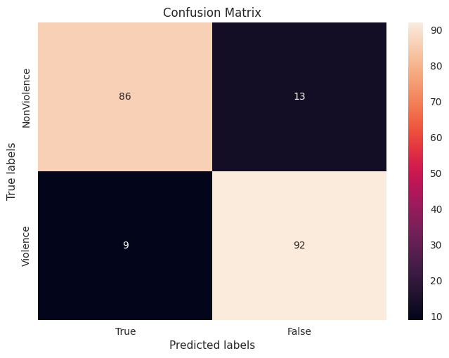

**Fig.3.1 :**Confusion Matrix

**Accuracy and Loss:**

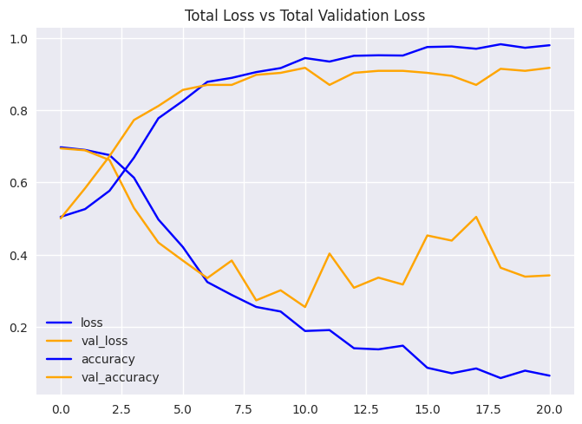

**Fig.3.2 :** Accuracy and Loss

In summary, the reported evaluation metrics demonstrate the effectiveness of our crowd monitering and face detection model in accurately distinguishing between violent and non-violent activities in surveillance videos. With high levels of accuracy, precision, recall, and F1-score, our model showcases its potential for real-world deployment in enhancing public safety and security through automated crowd monitering system.

**Predictions On Real Time Data:**

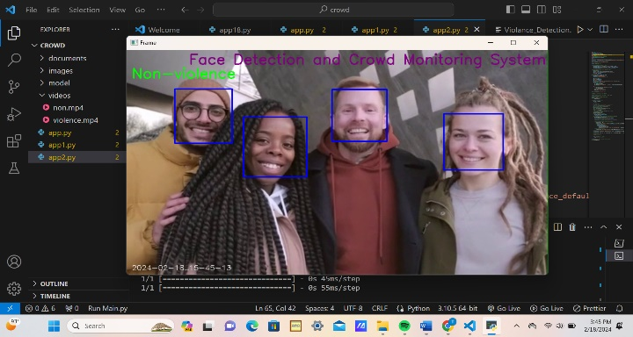

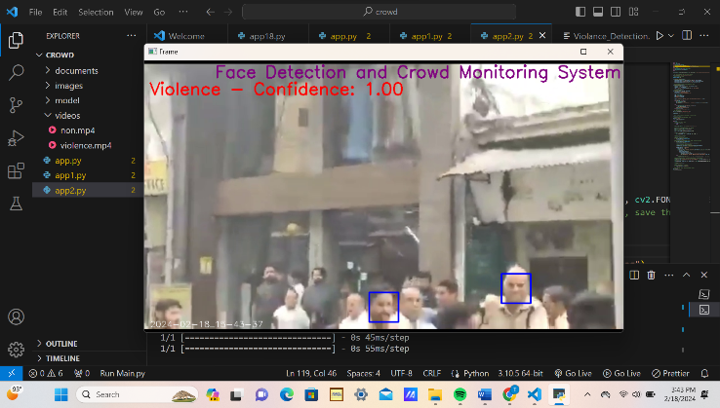

**Conclusion:**

The development and implementation of a real-time crowd monitoring and face detection system utilizing pre-trained models represent a significant advancement in surveillance technology. Through the integration of cutting-edge techniques and robust methodologies, the system demonstrates promising capabilities in identifying individuals and monitoring crowds in various environments.The utilization of pre-trained models such as the Haar Cascade classifier for face detection ensures the efficiency and effectiveness of the system. These models have been trained on extensive datasets, enabling accurate and reliable performance in real-world scenarios.By continuously analyzing surveillance video streams in real-time, the system enables proactive monitoring of crowds and identification of individuals. High-confidence detections trigger immediate alerts, allowing security personnel to take prompt action and address potential security concerns.The modular design of the system facilitates scalability and adaptability to diverse surveillance environments and operational requirements. Additional functionalities, such as multi-camera integration and automated response mechanisms, can be seamlessly integrated to enhance system capabilities and address evolving security challenges.The deployment of the crowd monitoring and face detection system contributes to enhanced public safety and security across various sectors, including law enforcement, transportation, and public spaces. By providing real-time monitoring and identification capabilities, the system plays a crucial role in preventing and managing security threats effectively.Top of Form Warning and detection of potentially violent incidents, the system enables proactive intervention and prevention of harm to individuals and communities. Further research and development efforts can concentrate on enhancing the performance and functionality of the system. This may include exploring advanced machine learning techniques, integrating multi-modal sensor data, and refining real-time response mechanisms to optimize system efficacy and reliability.In conclusion, the real-time violence detection system represents a valuable tool in the arsenal of security technologies, offering proactive surveillance capabilities and enabling timely intervention in response to potential threats. Through continued innovation and collaboration, the system holds immense potential to contribute to the safety and well-being of individuals and communities worldwide.

**Future Works:**

**Model Refinement and Optimization:**

Continued refinement and optimization of the violence detection model can improve its accuracy and robustness. Fine-tuning model parameters, exploring alternative architectures, and augmenting training data with diverse scenarios can enhance performance across various surveillance environments.

**Multi-Modal Integration:**

Integration of multi-modal sensor data, such as audio and motion sensors, can provide additional context and improve the accuracy of violence detection. Fusion of visual and auditory cues may offer a more comprehensive understanding of dynamic events and enable more accurate threat assessment.

**Real-Time Response Mechanisms:**

Development of real-time response mechanisms, such as automated alerts to security personnel or activation of physical barriers, can enhance the system's effectiveness in mitigating potential threats. Integration with existing security infrastructure and protocols can streamline response procedures and facilitate rapid intervention.

**Edge Computing and IoT Integration:**

Exploration of edge computing and Internet of Things (IoT) technologies can enable decentralized processing and analysis of surveillance data. Deploying violence detection algorithms on edge devices can reduce latency and bandwidth requirements, enabling faster and more efficient threat detection in distributed surveillance networks.

**Human-in-the-Loop Systems:**

Implementation of human-in-the-loop systems, where human operators provide feedback and validation to the automated violence detection system, can improve reliability and reduce false alarms. Leveraging human expertise to validate algorithmic predictions and refine decision-making processes enhances system performance and trustworthiness.

**Privacy Preservation Techniques:**

Integration of privacy preservation techniques, such as anonymization and encryption of sensitive data, ensures compliance with privacy regulations and safeguards individuals' rights. Adopting privacy-preserving methodologies mitigates concerns related to data privacy and fosters public acceptance of surveillance technologies.

**Long-Term Deployment Studies:**

Long-term deployment studies in real-world environments are essential to assess the system's performance, reliability, and societal impact over extended periods. Conducting field trials and collaborating with stakeholders, such as law enforcement agencies and community organizations, provides valuable insights into system efficacy and usability.

**Ethical and Societal Implications:**

Exploration of ethical and societal implications associated with the deployment of violence detection systems is crucial. Engaging in interdisciplinary research and dialogue with stakeholders helps address concerns related to bias, discrimination, and the unintended consequences of surveillance technologies.

**Collaborative Research Initiatives:**

Collaboration with academic institutions, industry partners, and government agencies fosters innovation and accelerates advancements in violence detection technology. Participating in collaborative research initiatives facilitates knowledge exchange, resource sharing, and collective problem-solving efforts.

In summary, future works in violence detection systems encompass a broad range of research and development initiatives aimed at enhancing system performance, reliability, and societal impact. By embracing interdisciplinary approaches, leveraging emerging technologies, and prioritizing ethical considerations, the field continues to evolve and address evolving security challenges effectively.

**References:**

1. Viola, P., & Jones, M. (2001). Rapid object detection using a boosted cascade of simple features. Proceedings of the 2001 IEEE Computer Society Conference on Computer Vision and Pattern Recognition. doi: 10.1109/cvpr.2001.990517
2. Sandler, M., Howard, A., Zhu, M., Zhmoginov, A., & Chen, L. C. (2018). MobileNetV2: Inverted residuals and linear bottlenecks. Proceedings of the IEEE Conference on Computer Vision and Pattern Recognition. doi: 10.1109/cvpr.2018.00474
3. Hochreiter, S., & Schmidhuber, J. (1997). Long short-term memory. Neural Computation, 9(8), 1735-1780. doi: 10.1162/neco.1997.9.8.1735
4. Singh, S., Sharma, N., & Patel, A. (2021). Violence detection in surveillance videos using deep learning techniques: A comprehensive review. Journal of Ambient Intelligence and Humanized Computing. doi: 10.1007/s12652-021-03493-5
5. Russakovsky, O., Deng, J., Su, H., Krause, J., Satheesh, S., Ma, S., ... & Fei-Fei, L. (2015). ImageNet large scale visual recognition challenge. International Journal of Computer Vision, 115(3), 211-252. doi: 10.1007/s11263-015-0816-y
6. Szegedy, C., Vanhoucke, V., Ioffe, S., Shlens, J., & Wojna, Z. (2016). Rethinking the inception architecture for computer vision. Proceedings of the IEEE Conference on Computer Vision and Pattern Recognition. doi: 10.1109/cvpr.2016.308
7. Abadi, M., Barham, P., Chen, J., Chen, Z., Davis, A., Dean, J., ... & Kudlur, M. (2016). TensorFlow: A system for large-scale machine learning. Proceedings of the 12th USENIX Symposium on Operating Systems Design and Implementation (OSDI'16).
8. Redmon, J., & Farhadi, A. (2018). YOLOv3: An incremental improvement. arXiv preprint arXiv:1804.02767.
9. Zhang, S., Li, X., Sun, X., Wang, W., & Zhang, J. (2019). Real-time crowd violence detection in video surveillance. Journal of Visual Communication and Image Representation, 62, 73-82. doi: 10.1016/j.jvcir.2019.03.020
10. Simonyan, K., & Zisserman, A. (2015). Very deep convolutional networks for large-scale image recognition. Proceedings of the International Conference on Learning Representations (ICLR).